SUBASHREE.N-192521377
LAB EXPERIMENTS
EXP 13:S imple programming usingCASE and LOOP

OUTPUT:
1:
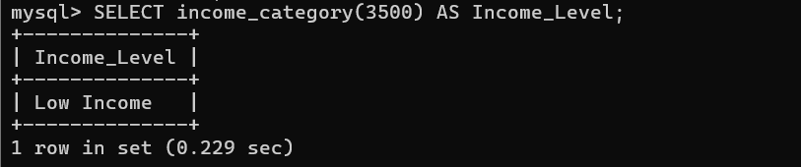
2:
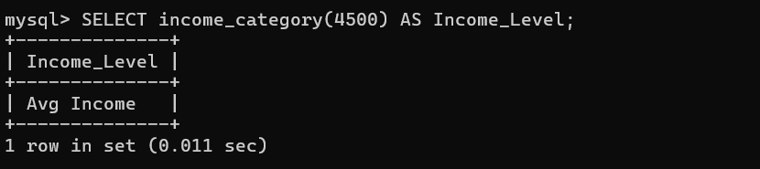
3:
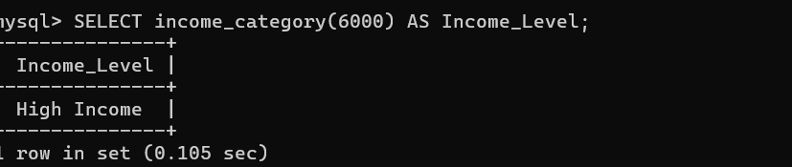
4:
